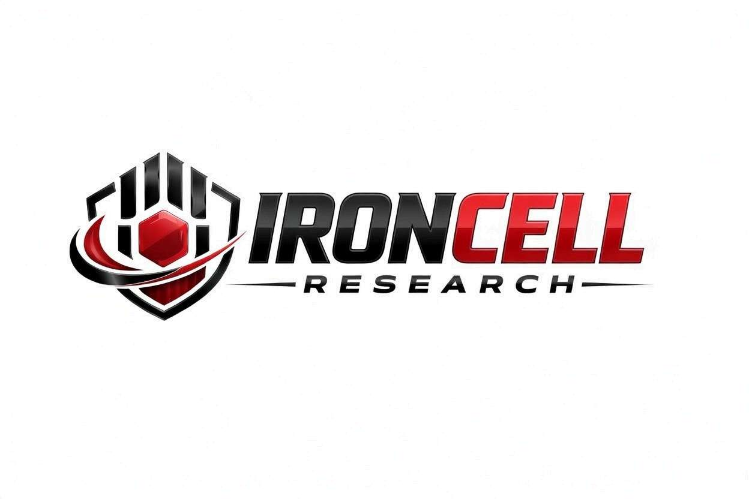
PEPTIDE RESEARCH BRIEF
Vitamin B12
Methylcobalamin / Cyanocobalamin | Essential Coenzyme for Energy & Neurological Function

Description, Benefits, Dosage & Research Overview

Iron Cell Research
IronCellResearch.com
For Research Use Only


Compound Overview
Compound Name | Vitamin B12 (Cobalamin)
Common Injectable Forms | Methylcobalamin (active) | Cyanocobalamin (standard) | Hydroxocobalamin (depot)
Classification | Water-Soluble Essential Vitamin / Cobalt-Containing Coenzyme
Molecular Formula | C63H88CoN14O14P (Cyanocobalamin)
Molecular Weight | 1355.37 g/mol
CAS Number | Cyanocobalamin: 68-19-9 | Methylcobalamin: 13422-55-4
Biological Half-Life | Approximately 6 days (circulating); liver stores last 3-5 years
Purity | USP / Pharmaceutical Grade
Storage | Room temperature or refrigerated, protected from light
Research Status | Extensively studied; FDA-approved injectable for deficiency and pernicious anemia

Description
Vitamin B12 (cobalamin) is an essential water-soluble vitamin and the largest and most structurally complex of all vitamins. It contains a corrin ring with a central cobalt atom and is unique among vitamins in that it cannot be synthesized by any plant or animal — it is produced exclusively by certain bacteria and archaea. Humans obtain B12 through animal-derived foods or supplementation.
B12 serves as a critical coenzyme for two essential enzymatic reactions in human metabolism: the conversion of methylmalonyl-CoA to succinyl-CoA (requiring adenosylcobalamin) and the remethylation of homocysteine to methionine (requiring methylcobalamin). These reactions are fundamental to DNA synthesis, red blood cell formation, neurological function, and one-carbon metabolism.
Injectable B12 bypasses gastrointestinal absorption barriers (intrinsic factor dependency, ileal receptor limitations) and achieves significantly higher bioavailability than oral supplementation. This makes injectable B12 the preferred route for individuals with absorption impairments, pernicious anemia, post-bariatric surgery patients, and those seeking optimal tissue saturation for energy, cognitive, and neurological support.

Forms of Injectable B12

Methylcobalamin
The bioactive coenzyme form that participates directly in methionine synthase reactions. Does not require hepatic conversion. Preferred for neurological support and methylation optimization. Has superior nervous system tissue retention compared to cyanocobalamin.

Cyanocobalamin
The most widely available and extensively studied synthetic form. Highly stable with a long shelf life. Requires enzymatic conversion to methylcobalamin or adenosylcobalamin in the body. FDA-approved standard for B12 deficiency treatment.

Hydroxocobalamin
A natural form produced by bacteria with superior tissue retention and a longer duration of action than cyanocobalamin. Binds more tightly to transport proteins (transcobalamin II), resulting in sustained B12 levels. Also used as a cyanide antidote (Cyanokit) due to its high affinity for cyanide ions.

Mechanism of Action

Methionine Synthase Pathway
Methylcobalamin serves as the essential cofactor for methionine synthase, which catalyzes the transfer of a methyl group from 5-methyltetrahydrofolate (5-MTHF) to homocysteine, regenerating methionine. Methionine is subsequently converted to S-adenosylmethionine (SAMe), the universal methyl donor for over 200 methylation reactions including DNA methylation, neurotransmitter synthesis, phospholipid production, and gene expression regulation.

Methylmalonyl-CoA Mutase Pathway
Adenosylcobalamin (formed from B12 in mitochondria) is the cofactor for methylmalonyl-CoA mutase, which converts methylmalonyl-CoA to succinyl-CoA in the mitochondrial matrix. This reaction is essential for the catabolism of odd-chain fatty acids, branched-chain amino acids (valine, isoleucine), and cholesterol side chains, feeding into the citric acid cycle for ATP production.

Homocysteine Regulation
B12's role in methionine synthase directly regulates plasma homocysteine levels. Elevated homocysteine (hyperhomocysteinemia) is an independent risk factor for cardiovascular disease, stroke, cognitive decline, and osteoporosis. Adequate B12 status is essential for maintaining homocysteine within the optimal range.

Myelin Synthesis & Nerve Function
B12 is essential for the synthesis and maintenance of the myelin sheath that insulates nerve fibers. Through SAMe-dependent methylation of phospholipids and proteins in myelin, B12 maintains nerve conduction velocity and protects against demyelination. B12 deficiency causes progressive, potentially irreversible neurological damage.

Research Benefits

Energy & Fatigue Reduction
- Cellular Energy Production: B12's role in succinyl-CoA formation directly supports mitochondrial ATP production through the citric acid cycle.
- Red Blood Cell Formation: Essential for normal erythropoiesis; deficiency causes megaloblastic anemia with large, dysfunctional red blood cells and impaired oxygen delivery.
- Fatigue Resolution: Injectable B12 rapidly corrects deficiency-related fatigue, weakness, and exercise intolerance, often within days to weeks.
- Adrenal Support: Supports methylation reactions critical for cortisol metabolism and adrenal hormone synthesis.

Neurological & Cognitive Function
- Myelin Protection: Maintains myelin sheath integrity, preventing peripheral neuropathy, numbness, tingling, and balance disturbances.
- Cognitive Performance: Adequate B12 status associated with better memory, processing speed, and reduced risk of cognitive decline in aging populations.
- Mood & Mental Health: SAMe production dependent on B12 supports synthesis of serotonin, dopamine, norepinephrine, and melatonin.
- Neuropathy Treatment: Methylcobalamin has demonstrated nerve regeneration properties in peripheral neuropathy research.

Cardiovascular Health
- Homocysteine Reduction: Lowers elevated homocysteine levels, reducing vascular inflammation and endothelial damage.
- Endothelial Function: Supports nitric oxide production and vascular health through methylation-dependent pathways.
- Lipid Metabolism: Participates in fatty acid metabolism and cholesterol processing.

Methylation & Detoxification
- SAMe Production: Drives the methionine-SAMe cycle, supporting over 200 methylation reactions essential for detoxification, hormone metabolism, and gene regulation.
- Glutathione Support: Methylation cycle feeds into transsulfuration pathway, supporting glutathione synthesis.
- DNA Methylation: Proper B12 status supports epigenetic regulation through DNA and histone methylation.

Immune Function
- Immune Cell Production: Essential for the rapid cell division required for lymphocyte and leukocyte production.
- NK Cell Activity: B12 status correlates with natural killer cell function and cytotoxic T-cell activity.
- Mucosal Immunity: Supports epithelial barrier function and mucosal immune defenses.

Dosage & Administration
The following dosage information is provided for research reference purposes only.
Protocol | Dose Range | Route | Frequency
Deficiency Treatment | 1000 mcg | IM or SubQ Injection | Daily x 7 days, then weekly x 4, then monthly
Maintenance | 1000 mcg | IM or SubQ Injection | Monthly or bi-weekly
Optimization Protocol | 1000-2500 mcg | SubQ Injection | 1-2x per week
Methylcobalamin | 1000-5000 mcg | SubQ or IM Injection | 1-3x per week (neurological support)

Administration Guidelines
Injectable Forms | Pre-filled ampules or multi-dose vials (typically 1000 mcg/mL)
Injection Route | Intramuscular (deltoid, gluteal) or subcutaneous
Volume | Typically 1 mL per injection
Storage | Room temperature (cyanocobalamin) or refrigerated (methylcobalamin); protect from light
Injection Site | IM: deltoid or ventrogluteal; SubQ: abdomen, thigh, upper arm
Timing | Any time of day; some prefer morning for energy benefits
Note | Methylcobalamin is light-sensitive; store in amber vials and protect from UV exposure

Safety Profile
Vitamin B12 has an exceptional safety profile with no established upper tolerable intake level:
- General Tolerability: Extremely safe even at high doses. B12 is water-soluble with excess excreted renally. No toxicity has been established at any studied dose.
- Injection Site: Mild, transient pain, redness, or swelling at injection site. IM injections may cause brief soreness.
- Allergic Reactions: Rare hypersensitivity reactions reported, primarily with cyanocobalamin. Hydroxocobalamin and methylcobalamin are alternatives for sensitive individuals.
- Skin: Rare acneiform eruptions reported with high-dose supplementation, typically resolving with dose adjustment.
- Drug Interactions: Metformin, proton pump inhibitors (PPIs), and H2 blockers reduce B12 absorption (oral route only; does not affect injectable).
- Renal Impairment: No dose adjustment needed; excess B12 is safely cleared by kidneys.
- Pregnancy & Nursing: Safe and essential during pregnancy and lactation. B12 requirements increase during pregnancy. FDA Pregnancy Category C (cyanocobalamin).

Key References
- Stabler SP. Vitamin B12 Deficiency. New England Journal of Medicine. 2013;368(2):149-160.
- Green R, et al. Vitamin B12 Deficiency. Nature Reviews Disease Primers. 2017;3:17040.
- Obeid R, et al. Vitamin B12 Intake from Animal Foods, Biomarkers, and Health Aspects. Frontiers in Nutrition. 2019;6:93.
- Andrès E, et al. Vitamin B12 (Cobalamin) Deficiency in Elderly Patients. Canadian Medical Association Journal. 2004;171(3):251-259.
- Wolffenbuttel BHR, et al. The Many Faces of Cobalamin (Vitamin B12) Deficiency. Mayo Clinic Proceedings: Innovations, Quality & Outcomes. 2019;3(2):200-214.
- Watanabe F, et al. Vitamin B12-Containing Plant Food Sources for Vegetarians. Nutrients. 2014;6(5):1861-1873.
- Scalabrino G. The Multi-Faceted Basis of Vitamin B12 (Cobalamin) Neurotrophism in Adult Central Nervous System. Neuroscience Research. 2009;65(4):323-332.

Contact & Information
Company | Iron Cell Research
Website | IronCellResearch.com
Email | orders@ironcellresearch.com
Product Support | Available via website contact form

Disclaimer
This document is intended for informational and research purposes only. Vitamin B12 is sold as a research compound and is not intended for human consumption. The information provided herein does not constitute medical advice, diagnosis, or treatment recommendations. All research applications should comply with applicable institutional, local, and federal regulations. Iron Cell Research makes no claims regarding the therapeutic efficacy of Vitamin B12 for any medical condition. Researchers should consult with qualified healthcare professionals and institutional review boards before initiating any research protocols involving human subjects.
Iron Cell Research - For Research Use Only


